**APPIUM INSTALLATION &SCRIPT EXECUTION**

Installation:

1. Download JAVA and Set Java Path

<https://www.oracle.com/technetwork/java/javase/downloads/index.html>

1. Download Eclipse
2. Download ANDROID SDK

<https://developer.android.com/studio/#Requirements>

1. Download Required SDK Packages

Eclipse🡪 Window🡪 Android SDK Manager

1. SetUp Android Environment Variables.

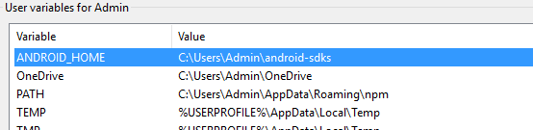

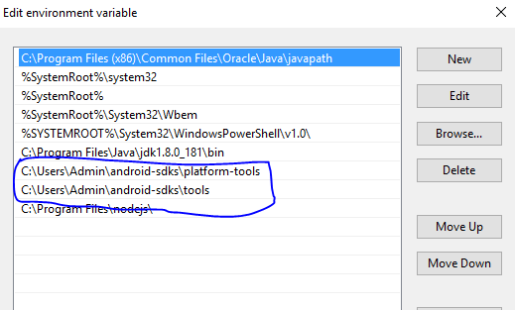

1. Download & Install NODEJS.

<https://nodejs.org/en/download/>

1. Download & Install Appium Desktop Client

<http://appium.io/downloads.html>

1. Enable Developer options in mobile

Settings🡪 about phone🡪 Click on Build Number until Developer option Enabled message is displayed.

1. Turn on USB Debugging

Developers options🡪 USB debugging (turn on)

**Object Identification**

1. Open AVD(Android Virtual Device Manager) and create AVD

Eclipse🡪 Android Virtual Device Manager and click Create and enter Details

1. Open AVD in Eclipse

Eclipse🡪 Window🡪 Android Virtual Device Manager

And Select AVD and Click Start button and Click Launch.

Android emulator will be opened.

1. Identify object Using **UI Automator Viewer.**

**C:\Users\Admin\android-sdks\tools\uiautomatorviewer.bat**

1. Click on below Image to get virtual Device in UI Automator viewer.

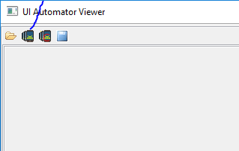

**How to Get Android App Package & Activity**

Open App in Device Manger or Mobile Phone & type below command in CMD.

adb shell "dumpsys window windows | grep -E 'mCurrentFocus|mFocusedApp'"

**How to know whether device is connected or not**

Open Cmd & type below command to get list of connected devices.

adb devices

**Run Appium Script**

Open Appium Desktop App and start the server.

**To run Hybrid Apps**

Connect Mobile using USB cable & make sure USB Debugging is turned ON.

**public** **class** Appium {

**public** **static** **final** String ***MobileElement*** = **null**;

AppiumDriver<WebElement> driver;

MobileElement appTitle;

WebDriverWait wait;

@SuppressWarnings("rawtypes")

@Test

**public** **void** nativeApps() **throws** MalformedURLException, InterruptedException {

DesiredCapabilities cap = **new** DesiredCapabilities();

cap.setCapability(MobileCapabilityType.***DEVICE_NAME***, "emulator-5554");

cap.setCapability(MobileCapabilityType.***NO_RESET***, **true**);

cap.setCapability(MobileCapabilityType.***NEW_COMMAND_TIMEOUT***, "100");

// Native App Calculator

cap.setCapability(AndroidMobileCapabilityType.***APP_PACKAGE***, "com.android.calculator2");

cap.setCapability(AndroidMobileCapabilityType.***APP_ACTIVITY***, "com.android.calculator2.Calculator");

cap.setCapability("platformName", "Android");

cap.setCapability("platformVersion", "5.1.1");

cap.setCapability("avd", "androidtest");

driver = **new** AndroidDriver<WebElement>(**new** URL("http://0.0.0.0:4723/wd/hub"), cap);

WebDriverWait wait = **new** WebDriverWait(driver, 100);

/*

* WebElement element =

* driver.findElementByXPath("//*[@content-desc='Calculator']");

*

* wait.until(ExpectedConditions.visibilityOf(element)); element.click();

*/

Thread.*sleep*(10000);

driver.findElementById("com.android.calculator2:id/digit_8").click();

driver.findElementById("com.android.calculator2:id/op_mul").click();

driver.findElementById("com.android.calculator2:id/digit_8").click();

}

@SuppressWarnings("unchecked")

@Test

**public** **void** playStore() **throws** MalformedURLException, InterruptedException {

DesiredCapabilities cap = **new** DesiredCapabilities();

cap.setCapability(MobileCapabilityType.***DEVICE_NAME***, "Galaxy J6");

cap.setCapability(MobileCapabilityType.***NO_RESET***, **true**);

cap.setCapability(MobileCapabilityType.***NEW_COMMAND_TIMEOUT***, "100");

cap.setCapability(AndroidMobileCapabilityType.***APP_PACKAGE***, "com.android.vending");

cap.setCapability(AndroidMobileCapabilityType.***APP_ACTIVITY***,"com.google.android.finsky.activities.MainActivity");

cap.setCapability("platformName", "Android");

cap.setCapability("platformVersion", "8.0.0");

// cap.setCapability("avd", "androidtest");

driver = **new** AndroidDriver<WebElement>(**new** URL("http://0.0.0.0:4723/wd/hub"), cap);

// String appName = "TeamViewer for Remote Control";

String appName = "Linux Commands for Beginners";

// How to scroll to specific text

/*

* MobileElement scrollToText = (MobileElement)

* driver.findElement(MobileBy.AndroidUIAutomator(

* "new UiScrollable(new UiSelector()).scrollIntoView(new UiSelector().text(\""

* + appName + "\"));")); scrollToText.click();

*

* // Verifying the app detail page appTitle = (MobileElement)

* driver.findElementById("com.android.vending:id/title_title");

* Assert.assertTrue(appName.equals(appTitle.getText().trim()));

* driver.navigate().back();

*/

MobileElement scrollToElement = (MobileElement) driver.findElement(MobileBy.*AndroidUIAutomator*(

"new UiScrollable(new UiSelector()).scrollIntoView(new UiSelector().description(\"Search\"));"));

scrollToElement.click();

MobileElement editText = (MobileElement) driver.findElementById("com.android.vending:id/search_box_text_input");

editText.sendKeys(appName);

Thread.*sleep*(5000);

List<WebElement> elements = driver.findElementsById("com.android.vending:id/suggest_text");

**for** (WebElement element : elements) {

**if** (appName.equals(element.getText().trim())) {

element.click();

**break**;

}

}

Thread.*sleep*(5000);

// appTitle = (MobileElement)

appTitle = (io.appium.java_client.MobileElement) driver.findElementById("com.android.vending:id/title_title");// com.android.vending:id/li_title

// appTitle = (MobileElement)

// driver.findElementById("com.android.vending:id/li_title");

Assert.*assertTrue*(appName.equals(appTitle.getText().trim()));

Thread.*sleep*(5000);

// driver.findElement(MobileBy.AndroidUIAutomator("new

// UiSelector().className(\"android.widget.TextView\").resourceId(\"com.android.vending:id/title\").text(\"INSTALL\")")).click();

driver.findElementByClassName("android.widget.Button").click();

Thread.*sleep*(5000);

// driver.findElementByClassName("android.widget.Button").click();

wait = **new** WebDriverWait(driver, 360);

wait.until(ExpectedConditions.*invisibilityOf*(driver.findElementById("com.android.vending:id/progress_bar")));

Thread.*sleep*(10000);

wait.until(ExpectedConditions.*visibilityOf*(driver.findElement(By.*xpath*(

"//android.view.ViewGroup[@resource-id='com.android.vending:id/item_details_panel']//android.view.ViewGroup/android.view.ViewGroup[@resource-id='com.android.vending:id/button_container']/android.widget.Button[1]"))));

driver.findElement(By.*xpath*(

"//android.view.ViewGroup[@resource-id='com.android.vending:id/item_details_panel']//android.view.ViewGroup/android.view.ViewGroup[@resource-id='com.android.vending:id/button_container']/android.widget.Button[1]"))

.click();

Thread.*sleep*(3000);

driver.findElementById("android:id/button1").click();

Thread.*sleep*(5000);

wait.until(ExpectedConditions.*visibilityOf*(driver.findElement(By.*xpath*( "//android.view.ViewGroup[@resource-id='com.android.vending:id/item_details_panel']//android.view.ViewGroup/android.view.ViewGroup[@resource-id='com.android.vending:id/button_container']/android.widget.Button[1]"))));

WebElement installButton = driver.findElement(By.*xpath*( "//android.view.ViewGroup[@resource-id='com.android.vending:id/item_details_panel']//android.view.ViewGroup/android.view.ViewGroup[@resource-id='com.android.vending:id/button_container']/android.widget.Button[1]"));

**if** (installButton.isDisplayed()) {

Assert.*assertTrue*(**true**, "App UnInstalled Successfully");

} **else** {

Assert.*assertTrue*(**false**, "App UnInstalled Successfully");

}

}

}